SQL PROBLEMS (Basic to Advance)

PROBLEM-1:

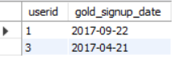

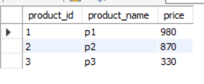

table: goldusers_signup Table: product

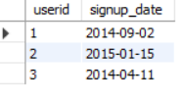

Table: users

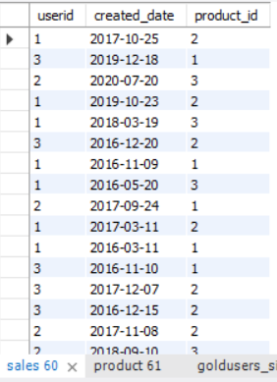

Table: sales

CODE FOR ABOVE TABLES:

use class;

CREATE TABLE goldusers_signup(userid integer,gold_signup_date date);

INSERT INTO goldusers_signup(userid,gold_signup_date)

VALUES (1,'2017-09-22'),

(3,'2017-04-21');

CREATE TABLE users(userid integer,signup_date date);

INSERT INTO users(userid,signup_date)

VALUES (1,'2014-09-02'),

(2,'2015-01-15'),

(3,'2014-04-11');

CREATE TABLE sales(userid integer,created_date date,product_id integer);

INSERT INTO sales(userid,created_date,product_id)

VALUES

(3,'2019-12-18',1),

(2,'2020-07-20',3),

(1,'2019-10-23',2),

(1,'2018-03-19',3),

(3,'2016-12-20',2),

(1,'2016-11-09',1),

(1,'2016-05-20',3),

(2,'2017-09-24',1),

(1,'2017-03-11',2),

(1,'2016-03-11',1),

(3,'2016-11-10',1),

(3,'2017-12-07',2),

(3,'2016-12-15',2),

(2,'2017-11-08',2),

(2,'2018-09-10',3);

CREATE TABLE product(product_id integer,product_name text,price integer);

INSERT INTO product(product_id,product_name,price)

VALUES(1,'p1',980),(2,'p2',870),(3,'p3',330);

select * from sales;

select * from product;

select * from goldusers_signup;

select * from users

1.What is the total amount each customer spent on zomato ?

select s.userid,sum(p.price) total_spent from sales as s inner join product as p on s.product_id = p.product_id group by userid;

OUTPUT: 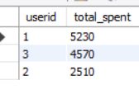

2.How many days each customer visted zomato ?

select s.userid,count(s.created_date) as No_Of_Days from sales s inner join users u on s.userid = u.userid group by userid

Both are gives same result

select userid,count( distinct created_date) as Distinct_days from sales group by userid

OUTPUT: 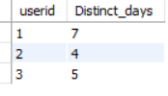

3.what was the first pruduct purchased by each customer ?

select * from

(select *,rank() over(partition by userid order by created_date) rank_1 from sales) a where rank_1=1

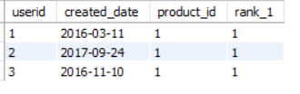

4.What is the most purchased item on the menu and how many times it was it purchased by all customer ?

select * from

(select product_id,count(created_date) No_times from sales group by product_id order by count(product_id) desc) a where No_times=7;



select userid,count(created_date) from sales where product_id=2 group by userid order by userid;

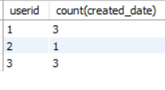

5.which item was the most popular for each customer?

select * from

(select *,rank() over(partition by userid order by cnt desc) rank_1 from

(select userid,product_id as Fav_product,count(product_id) cnt from sales group by userid,product_id) a)b where rank_1=1;

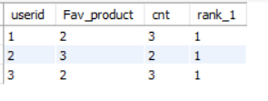

6. Which item was purchased first by the customer after they become a gold member ?'/

select * from

(select *,rank() over(partition by userid order by created_date) rank_ from

(select s.userid,s.created_date,s.product_id,g.gold_signup_date from sales s inner join goldusers_signup g

on s.userid = g.userid where created_date>=gold_signup_date) a)b where rank_=1;

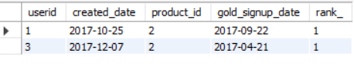

7.Which item was purchased just before the customer become a gold member ?'/

select * from

(select *,rank() over(partition by userid order by created_date desc) rank_1 from

(select s.userid,s.created_date,s.product_id , g.gold_signup_date from sales s inner join goldusers_signup g

on s.userid=g.userid and created_date <= gold_signup_date ) a )b where rank_1=1;

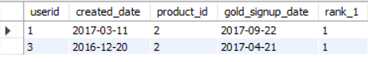

8.What is the total orders and amount spent for each member before they becom a gold member

select userid customer,count(created_date) Order_purchased,sum(price) Total_amount from

(select a.*,p.price from

(select s.userid,s.created_date,s.product_id,g.gold_signup_date from sales s inner join goldusers_signup g

on s.userid = g.userid and created_date<= gold_signup_date)a inner join product p on a.product_id= p.product_id) b group by userid;

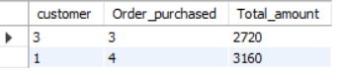

9. 'If buying each product genartes points for eg 5rs=2 zomato points each product has different purchasing points for eg

p1 5rs=1 zomato point , for p2 10rs=5 and p3 5rs=1 zomato point

calculate points collected by each customer and for which product most points have been given till now ?

select userid, sum(total_points) * 2.5 cashback from

(select c.*, amt/point_ total_points from

(select *,case when product_id =1 then 5 when product_id= 2 then 2 when product_id=3 then 5 else 0 end point_ from

(select a.userid,a.product_id,sum(price) amt from

(select s.*,p.price from sales s inner join product p on s.product_id = p. product_id) a

group by userid,product_id )b)c)d group by userid order by userid;

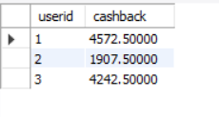

code for product:

select f.* from

(select e.*,rank() over( order by total desc) rak from

(select product_id, sum(total_points) total from

(select c.*, amt/points total_points from

(select product_id, amt, case when product_id=1 then 5 when product_id=2 then 2 when product_id=3 then 5 else 0 end points from

(select userid,product_id,sum(price) amt from

(select s.*,p.price from sales s inner join product p on s.product_id = p.product_id)a group by userid,product_id)b)c)d group by product_id order by product_id)e) f where rak=1

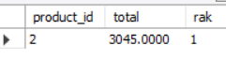  
10. Rank all the transaction of the customer ?'

select *, rank () over(partition by userid order by created_date) rank_ from sales

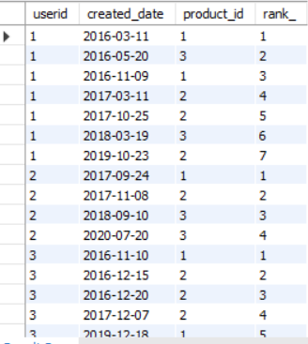

11.rank all the transaction for each member whenever they are a zomato gold member for every non gold member transation mark as na' ?

select b.* , case when rank_1= 0 then 'N/A' else rank_1 end as rank_2 from

(select a.*,case when gold_signup_date is null then 0 else rank() over(partition by userid order by created_date desc) end as rank_1 from

(select s.userid,s.created_date,s.product_id,g.gold_signup_date from sales s left join goldusers_signup g

on s.userid = g.userid and created_date>=gold_signup_date)a)b

